# Editing Banner

## Table of Contents

1. Navigating to Smart Slider
2. Choosing Slides
3. Add a Slide(s)
4. Choose The Type of Slide
5. Upload or Select Image
6. Save Slides

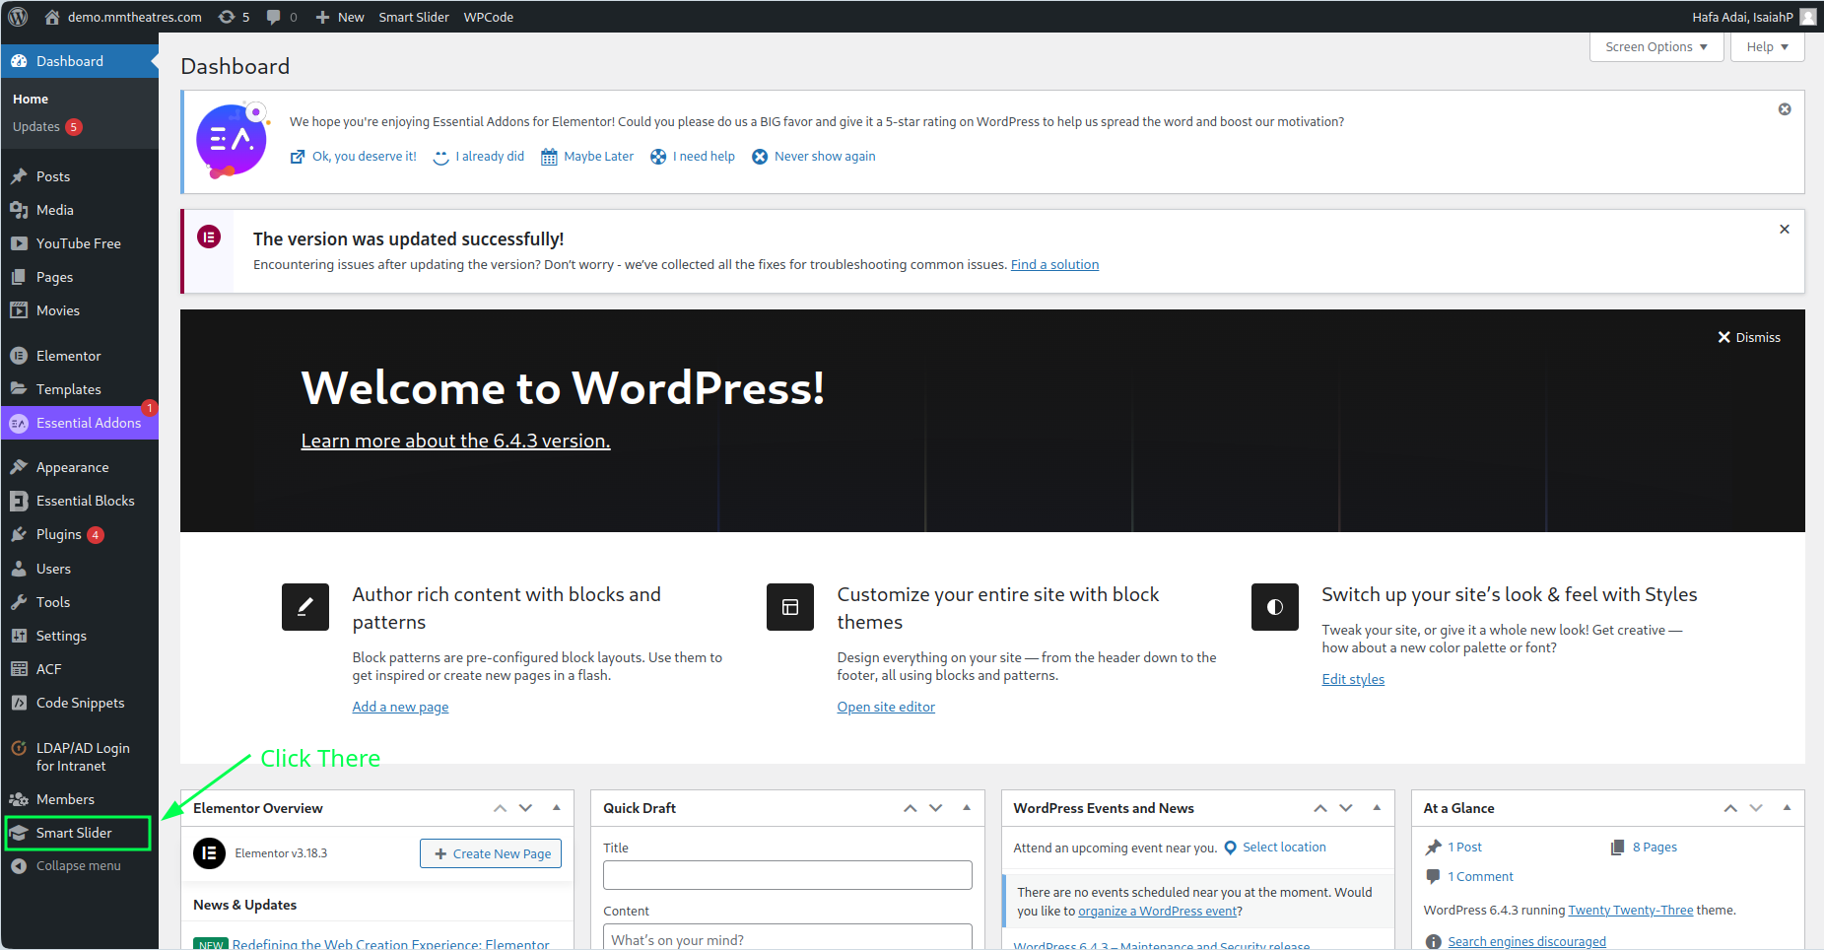

# Navigating to Smart Slider

If the image below can’t be seen, place the cursor in the dark gray sidebar and scroll up until the words dashboard appears. Search for it and if still can’t be fount, scroll down and repeat.

If it still appears to be lost, contact the admin as you might not have privilege to access it with the role assign to you.

## Smart Slider Can’t Be Found

What Smart Slider Looks like

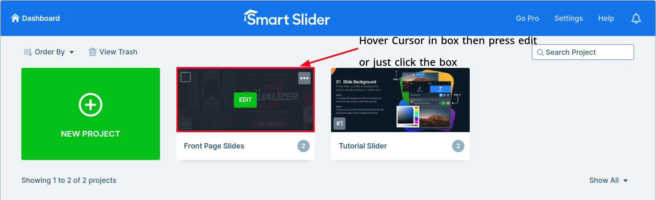

# Choosing Slides

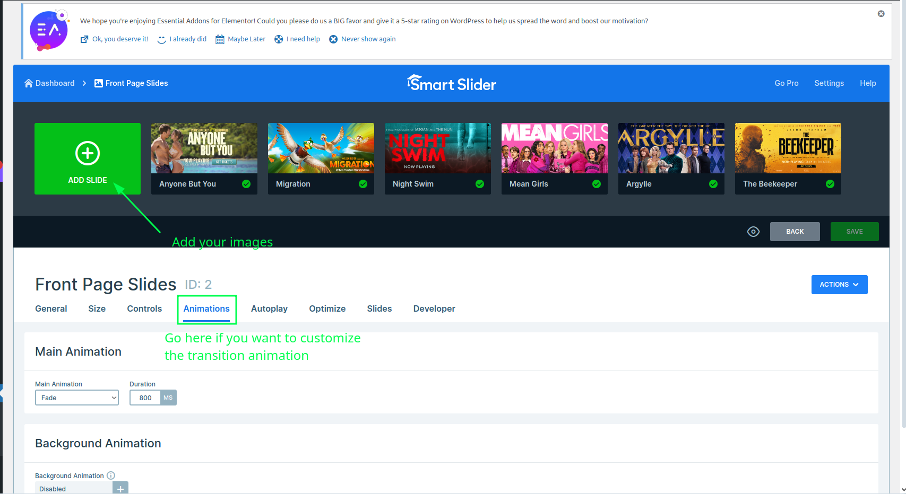

# Add a Slide



# Choose The Type Of Slide

Choose Image

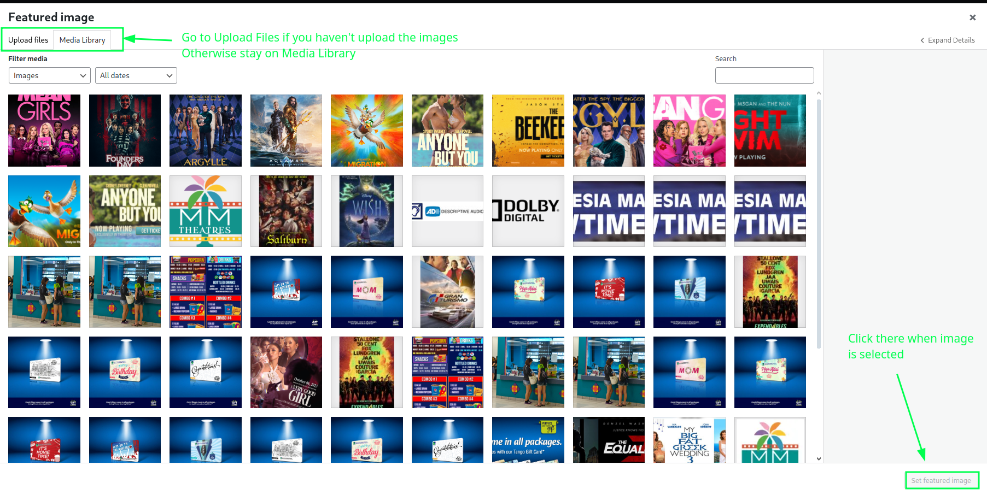

# Upload or Select Image

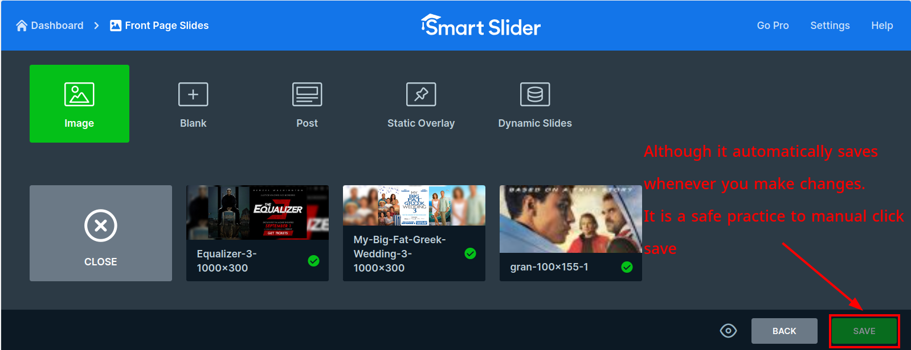

# Save Slides